***Responding to Requests with HTML Files***

<http://www.expressjs.com/en/4x/api.html#res.send>

**res.sendFile(“location”);**  //For whole file

if path is not known then check by console.log(__dirname);

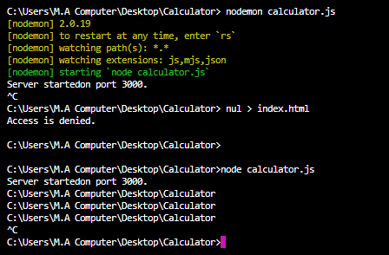

Create another file path.js and check paths there

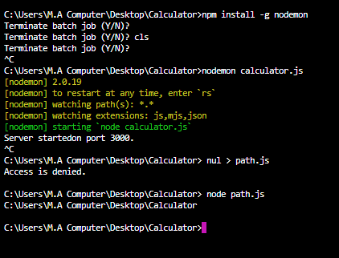

res.sendFile(path [, options] [, fn])

res.sendFile() is supported by Express v4.8.0 onwards.

**Index.html:**

<!DOCTYPE html>

<html lang="en" dir="ltr">

<head>

<meta charset="utf-8">

<title>Calculator</title>

</head>

<body>

<h1>Calculator</h1>

<form action="index.html" method="post">

<input type="text" name="num1" value="First Number">

<input type="text" name="num2" value="Second Number">

<button type="submit" name="submit">Calculate</button>

</form>

</body>

</html>

**Calculator.js:**

//jshint esversion:6

const express = require('express');

const app = express();

app.get("/", function(req, res){ //callback function

//res.send("Hello, World!");

//res.sendFile("index.html");

res.sendFile(__dirname + "/index.html");

});

app.listen(3000, function(){

console.log("Server is running at Port 3000.");

});

